H.T No
Regulations:
A17

Sreenidhi Institute of Science and Technology
(An Autonomous Institution)
Code No: 6A242 Date: 18-Feb-2025 (FN)

B.Tech I-Year II- Semester External Examination, February-2025 (Supplementary)
NETWORK ANALYSIS (ECE and ECM)

Time: 3 Hours Max.Marks:75
Note: a) No additional answer sheets will be provided.
b) All sub-parts of a question must be answered at one place only, otherwise it will not be valued.
c) Missing data can be assumed suitably.

Bloom's Cognitive Levels of Learning (BCLL)

Remember | L1 | Apply | L3 | Evaluate | L5
Understand | L2 | Analyze | L4 | Create | L6

Part - A Max.Marks:25

Answer all QUESTIONS.
 |  | BCLL | CO(s) | Marks
1 | Distinguish between an independent source and a dependent source. | L3 | CO1 | [2M]
2 | Define (i) Oriented graph (ii) tree of a graph. | L1 | CO2 | [2M]
3 | Derive expression for coefficient of coupling. | L4 | CO3 | [2M]
4 | State Norton’s theorem. | L1 | CO4 | [2M]
5 | Define i) Propagation constant and ii) Attenuation constant for a filter. | L1 | CO5 | [2M]
6 | Why the current in a pure inductor cannot change in zero time. | L2 | CO6 | [3M]
7 | Compare active and passive elements. | L3 | CO1 | [3M]
8 | Define RMS value | L1 | CO4 | [3M]
9 | Draw the equivalent network of Z-parameters. | L3 | CO5 | [3M]
10 | List the properties of series resonance circuit. | L1 | CO6 | [3M]

Part – B Max.Marks:50
ANSWER ANY FIVE QUESTIONS. EACH QUESTION CARRIES 10 MARKS.

 |  |  | BCLL | CO(s) | Marks
11. |  | For the circuit given find current through 30Ω resistor using mesh current method.  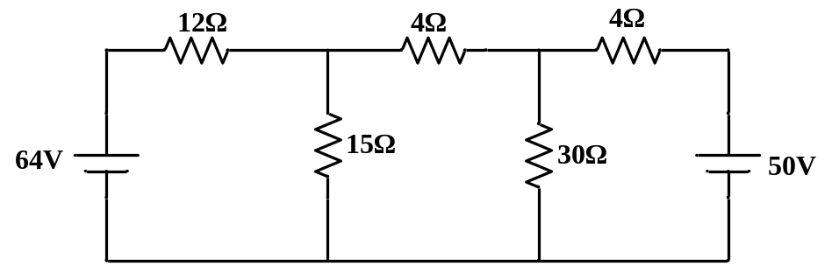 | L4 | CO1 | [10M]
12. | a) | Define cut-set matrix and tie-set matrix. | L1 | CO2 | [5M]
 | b) | Construct dual network for the network shown below.  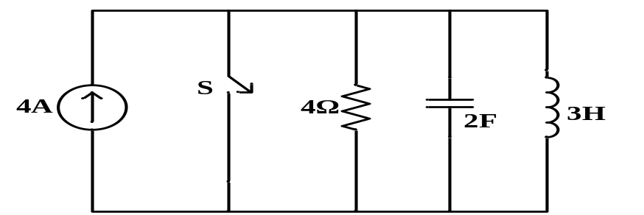 | L3 | CO2 | [5M]
13. | a) | Draw and explain power triangle. | L3 | CO3 | [5M]
 | b) | Explain the concept of dot convention. | L2 | CO3 | [5M]
14. |  | Calculate the current through 3Ω resistor in the circuit given using superposition theorem.  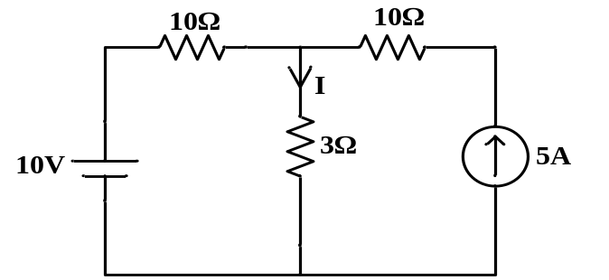 | L5 | CO4 | [10M]
15. | a) | A two port network has the following parameters  Z₂₂=40Ω, Z₁₁=30Ω and Y₁₂=0.05Ʊ. Calculate ABCD parameters. | L3 | CO5 | [5M]
 | b) | Explain series connection of two-port network. | L2 | CO5 | [5M]
16. |  | A series R-L circuit with R=60Ω and L=30H has a constant voltage V=120V applied at t=0. Determine the current, voltage across resistor and voltage across inductor.  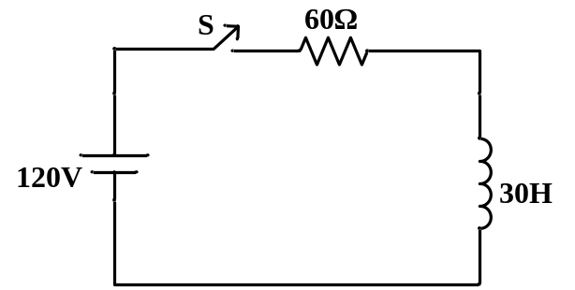 | L5 | CO6 | [10M]
17. | a) | Derive expression for star-delta transformation. | L4 | CO1 | [5M]
 | b) | What is the relation between resonant frequency and half power frequencies? | L3 | CO2 | [5M]
18. | a) | State and explain Millman’s theorem. | L1 | CO4 | [5M]
 | b) | Classify different types of filters based on frequency characteristics | L3 | CO5 | [5M]

-- 00 -- 00 –

